RICE SELECTION

* KABSA CHICKEN (RM6.00)

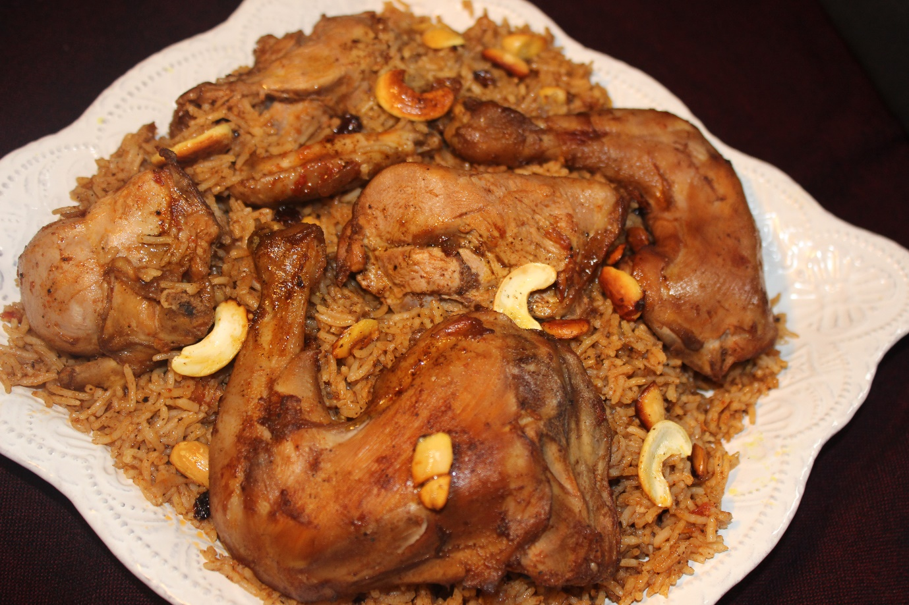

* KABSA LAMB (RM10.00)

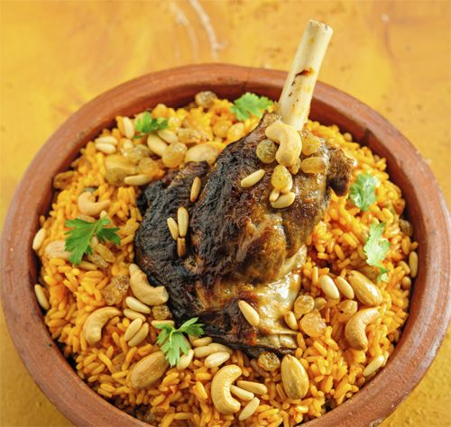

* MANDY CHICKEN (RM6.00)

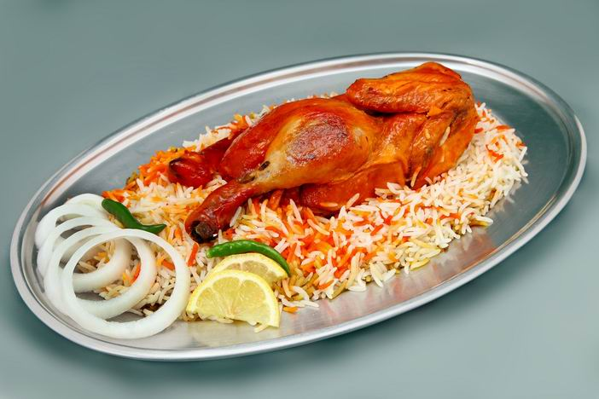

BARBECUE

* KEBAB LAMB (RM6.00)

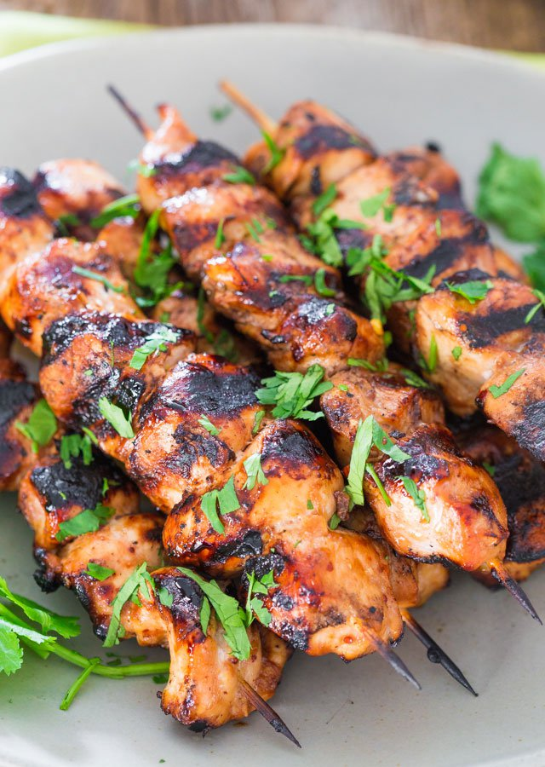

* KEBAB CHICKEN (RM5.00)

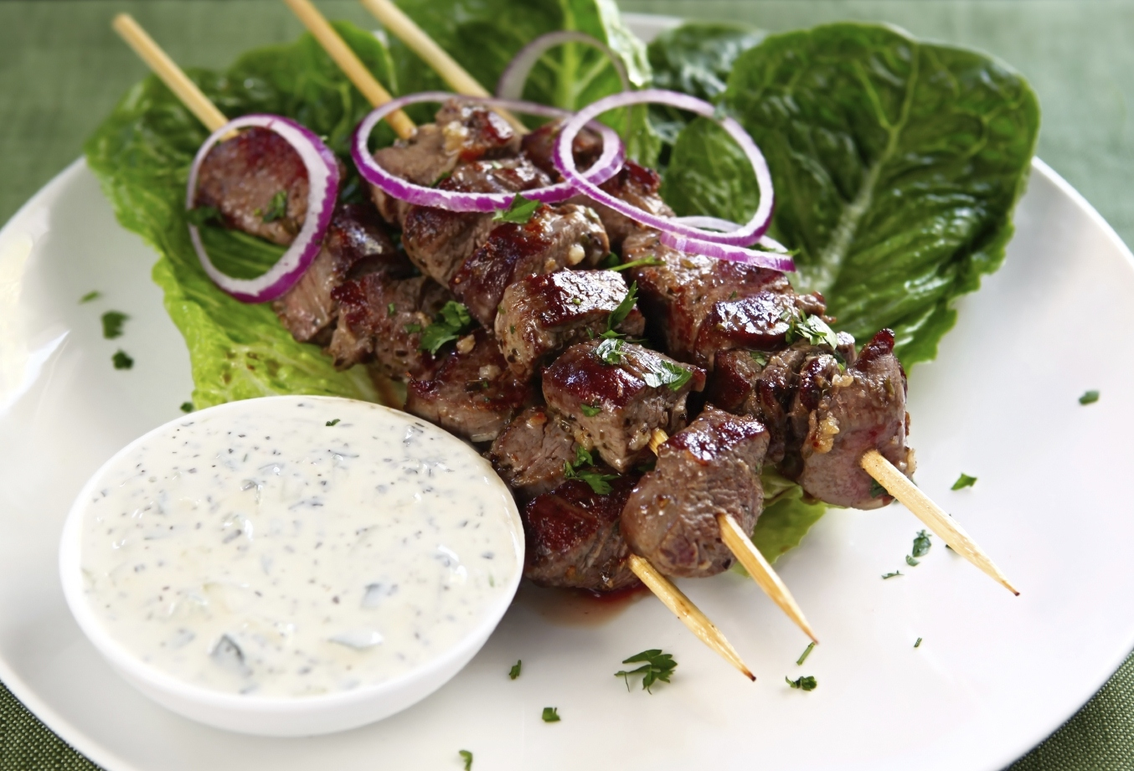

VEGETARIAN SELECTION

* FALAFEL SANDWICH (RM4.00)

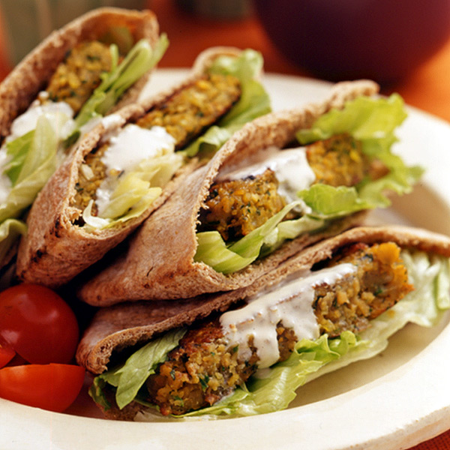

* HUMMUS (RM5.00)

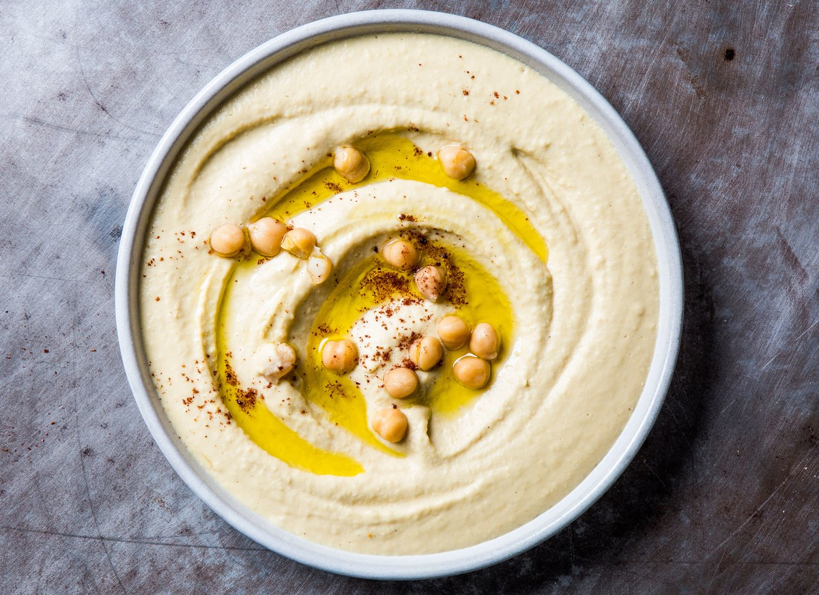

* DALLAH SALAD (RM4.00)

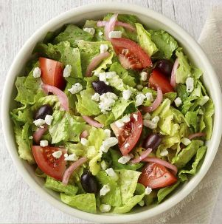

* FALAFEL & HUMMUS PLATE (RM10.00)

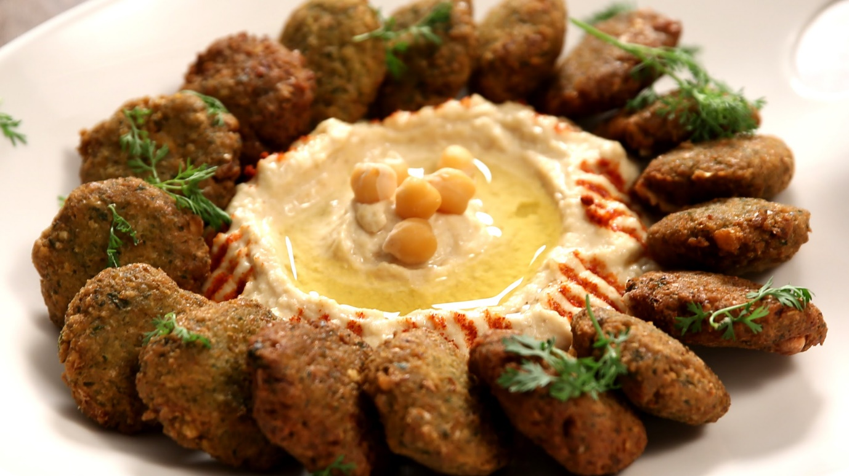

SHAWARMA CHICKEN

* SANDWICH (RM5.00)

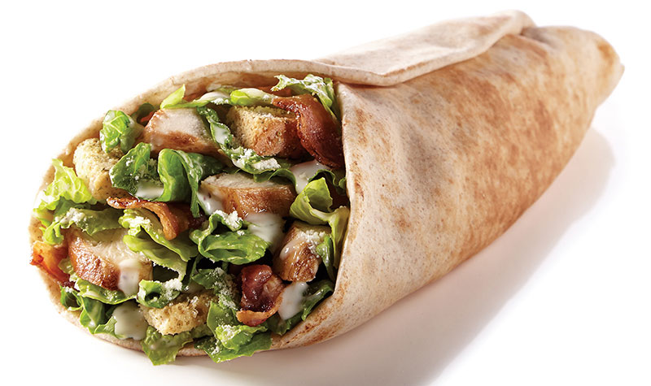

* PLATE (RM10.00)

